|  |
| --- |
| System On Chip (ELEC-4475-01-F15) |
| Lab 5 |
| Lab Report |
|  |
| **William Putnam & Jeff Falberg** |
| **11/18/2015** |

|  |
| --- |
|  |

Contents

Introduction 1

Design Methodology 1

Verification 2

Conclusion 2

# Introduction

The first lab project was the NES Controller, which required VHDL code to generate signals and read button press input from the hardware. The next lab project was the first step in graphics, which involved hardcoding the video graphics array (VGA) in VHDL to display the eight possible colors on the screen. The third lab expands on this by creating VGAs for creating the tile-map and creating a VGA to display 64 pixels of sprites on the tiles for the character sprite and items. The fourth lab introduces using pointers with C Programming to control the microcontroller, using two methods to control the speed of the LED-flashing pattern, a "for" loop and the xtmrctr timer.

For the fifth lab, the previous four all contributed to its creation. The first lab provided the foundation for reading from the buttons of the NES Controller to the microcontroller board. The second and third labs helped show how to create the sprites and tiles on the screen via VGA for our playable character, object, and background. Lastly, the fourth lab showed how to use the timer in C Programming so that we could paint the screen.

# Design Methodology

**Lab 1**

We created the first lab by first creating the VHDL code for generating signals and for reading the button input from the controller. The entity had the reset, clock, and NESdatIN as inputs and the buttenLED, NESlatch, and NESclk as outputs. This lab required the latch to have a 12us high signal and for the pulse to have a 12us per cycle. The latch will tell the controller to capture the button state and the pulse moves each button through the data output.

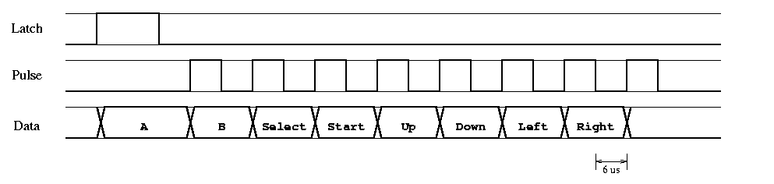

Figure 1: Timing required for Lab 1

# Verification

(Include pictures of the different components working)

# Conclusion

(Summarize project, how we could have improved it)